# Instructions to use the DevOps PoT on Cloud remotely

Regi Barosa – June 28, 2019

Be sure that you have the **provided link to access the cloud instance**, the userid (**Administrator**) and **password** to access the Windows VMWARE client remotely.  
Use COPY/PASTE for password.   
Some letters may be identical, example: **I (**uppercase i) and **l** (lowercase L).  
Example  


Below is what you will access on the cloud environment.  
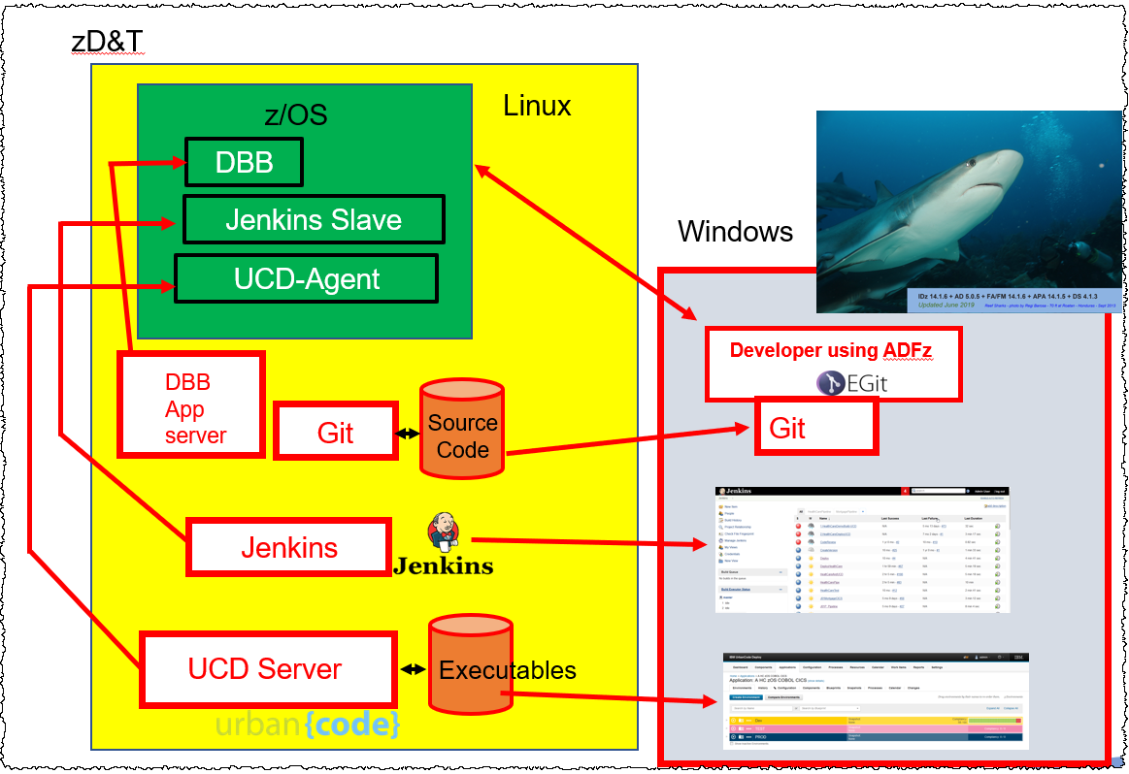

Be sure that you have an IP address, the userid ( Userid will be different if using **Remote Desktop** or **Browser** ) and password to access the Windows VMWARE client remotely.  
On the picture below you see what is on the cloud.

## Using Windows Remote Desktop

This is the preferable way to run the labs, but in some customer location this capability is blocked via Firewalls. If this is your case, use the Web Browser. Instructions are listed here as well..   
If you are a Mac user may consider downloading the Remote desktop from <https://itunes.apple.com/us/app/microsoft-remote-desktop-10/id1295203466?mt=12>

1. Using windows start the **Remote Desktop** .   
   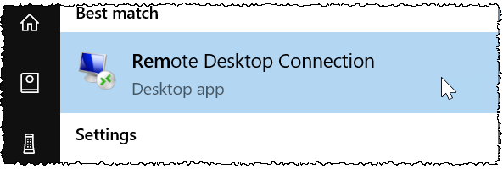
2. Click **Show Options**  
   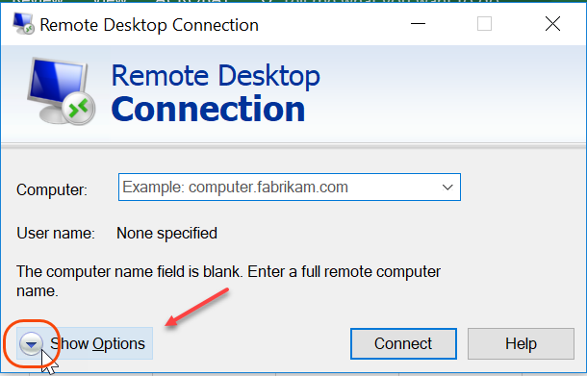
3. Use the **IP value** given to you by the instructor (the value below is an example)   
   and xxxxxx\**Administrator** as *user name* **allow to save credentials** and click **Connect**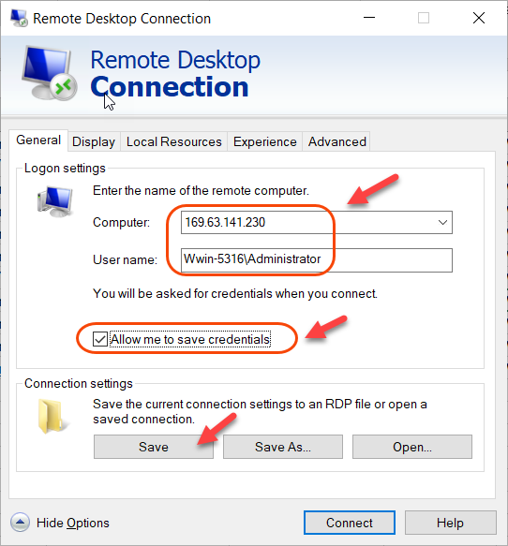
4. Click **More choices**   
     
   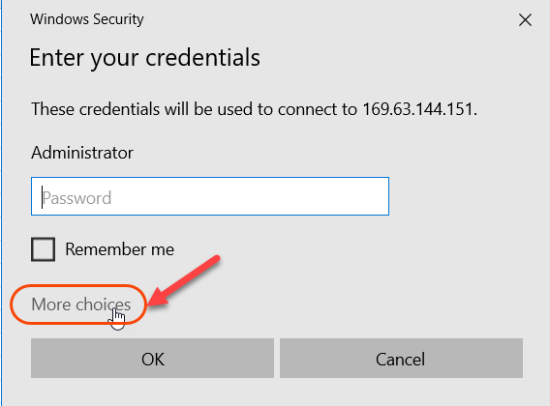
5. Click **Use a different account**, type your name AGAIN ( xxxxxx\**Administrator** )   
   **the password** (MUST copy/paste to avoid wrong characters) , click **Remember me** and click **OK**  
   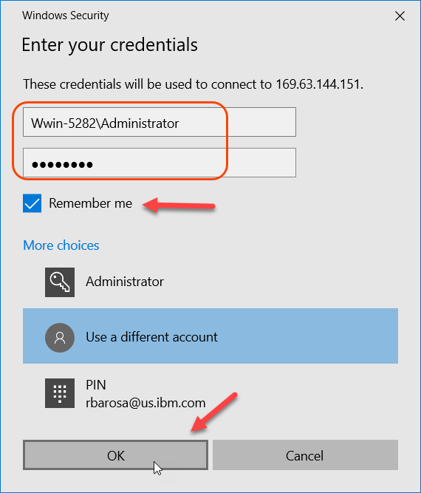
6. Type the **password provided** by the instructor and click **OK**
7. You should get a screen with a shark. That indicate that you have access to the Windows client on cloud.  
   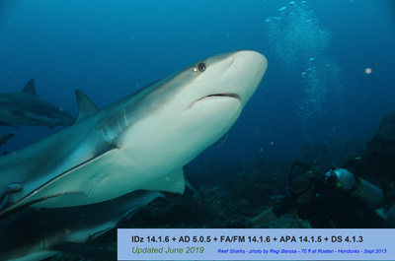
8. On the windows desktop there is a PDF icon with the workbook.. I suggest to print to better follow the instructions or use another Monitor to follow the lab instructions.

# C:\Users\REGINA~1\AppData\Local\Temp\SNAGHTML283820b7.PNGInstructions to use the DevOps PoT remotely using Web Browser

Regi Barosa – June 28 2019

Be sure that you have the **provided link to access the cloud instance**, the userid (**Administrator**) and **password** to access the Windows VMWARE client remotely.  
Use COPY/PASTE for password.   
Some letters may be identical, example: **I (**uppercase i) and **l** (lowercase L).  
Example  


## Using the Web Browser to access remotely the Windows (Avoid IE Browser)

1. Use the link provided by the instructor and type **Administrator/password** provided and click **Sign in**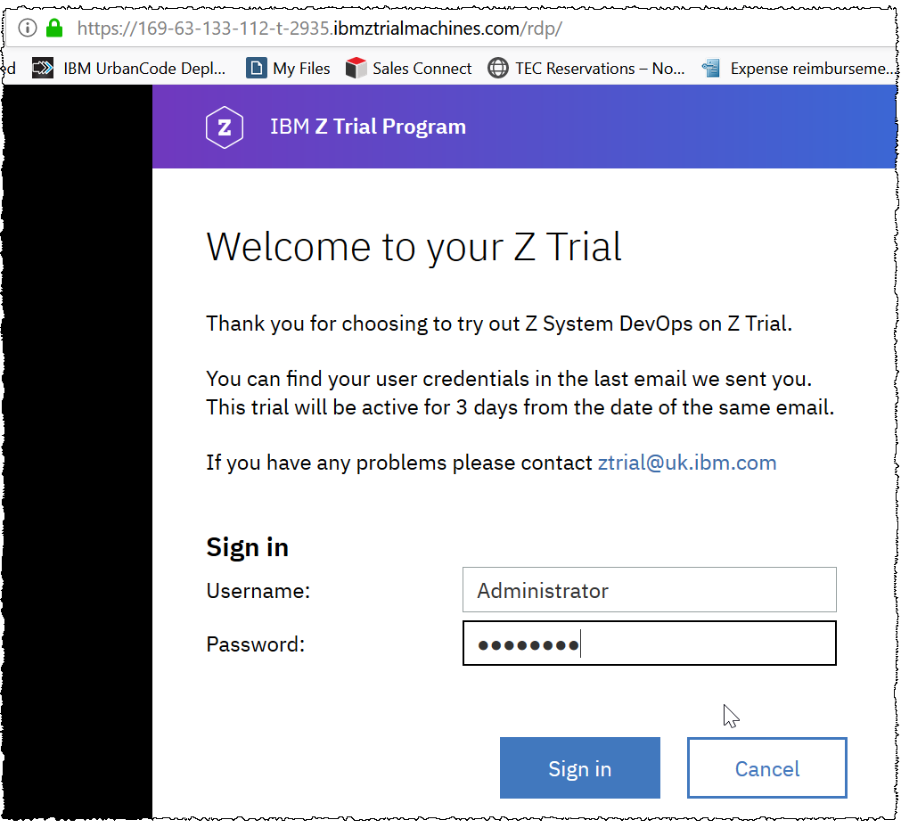
2. We are going to go full screen, so click on the **small mark** as seen below  
   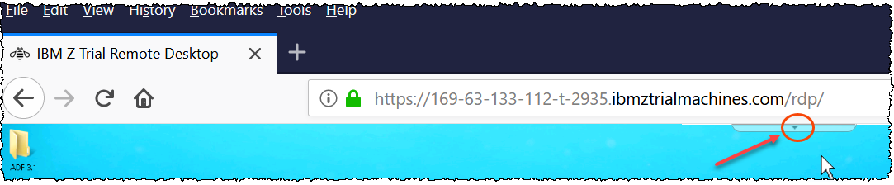
3. Click on **Actions**  
   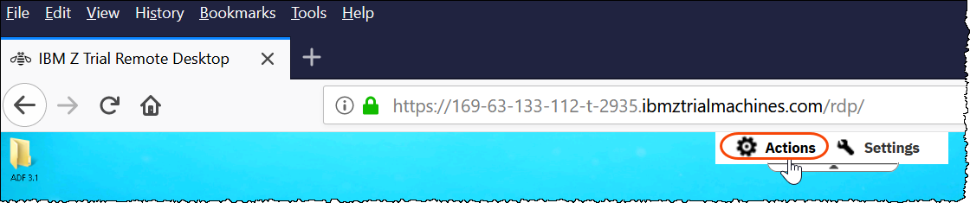
4. Select **Full Screen**.. This will eliminate the space on the right of the browser..  
     
   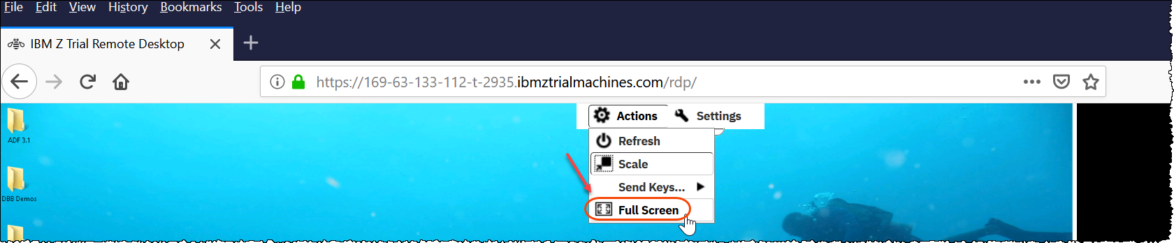
5. You are ready to start the labs.. **ESC** key will show the browser back..

**ISSUES with the Firefox Browser? Right click is not working?** 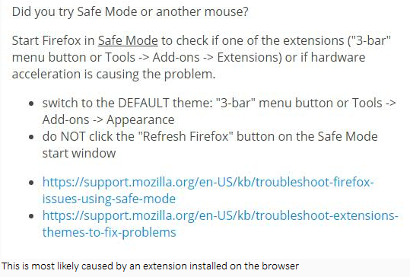

## **Is the screen resolution too small?**

You may try change the settings as below..

Go to **control panel** of the Windows machine   
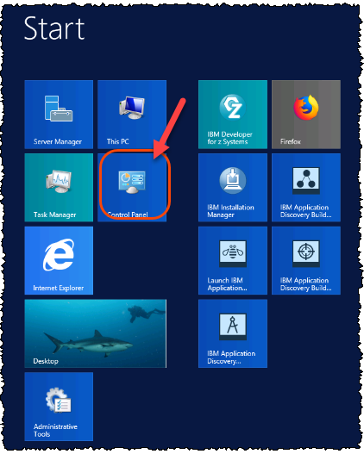  
  
Select **Fonts**

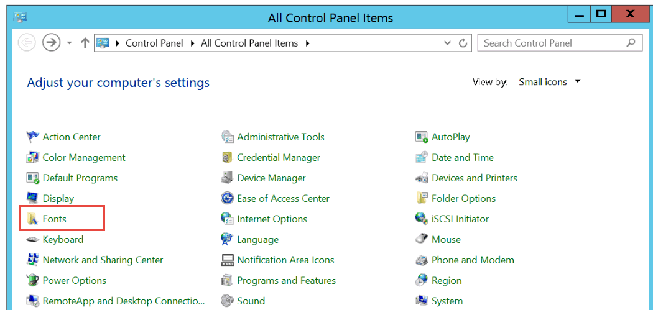

On the next scree. Click on **Change font size**

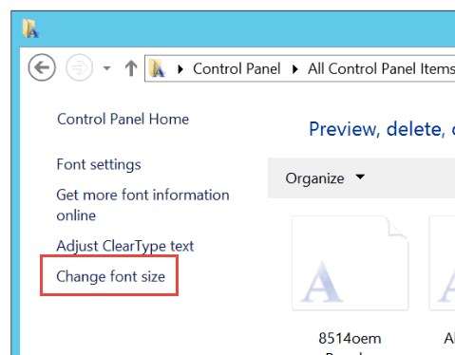

On the next one click on "**Let me choose on scaling level for all my display**" text box

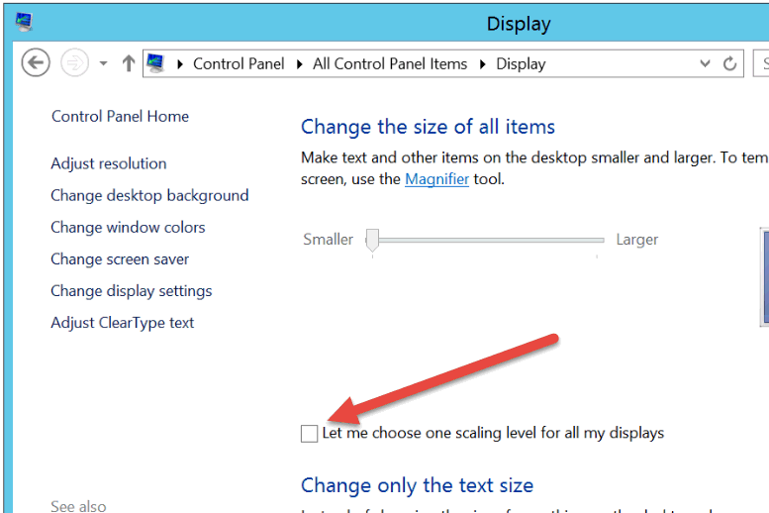

On the next one you can choose how big you want the font should be. **Try 125%** as seen below.   
If still small go to 150%  
  
This will require user to **disconnect and reconnect**.

